**ART GENERATION WITH NEURAL STYLE TRANSFER**

PROJECT REPORT

Submitted

*in the partial fulfillment of the requirements for the award of the degree of*

**BACHELOR OF TECHNOLOGY**

in

**COMPUTER SCIENCE AND ENGINEERING**

by

**BIRUDHURAJU ASHISH PREETHAM 20B81A0566**

**PAKA SREENIDHI 20B81A05A7**

Under the guidance of

**N.N.S.S.S. Adithya**

**Assistant Professor**

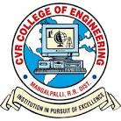

**DEPARTMENT OF COMPUTER SCIENCE AND ENGINEERING**

**CVR COLLEGE OF ENGINEERING**

**(*An Autonomous institution, NBA, NAAC Accredited and Affiliated to JNTUH, Hyderabad*)**

Vastunagar, Mangalpalli (V), Ibrahimpatnam (M),  
Rangareddy (D), Telangana- 501 510

**April 2024**

**CVR COLLEGE OF ENGINEERING**

(An UGC Autonomous Institution, Affiliated to JNTUH, Accredited by NBA, and NAAC)

Vastunagar, Mangalpalli (V), Ibrahimpatnam (M), Ranga Reddy (Dist.) - 501510, Telangana State.

**DEPARTMENT OF COMPUTER SCIENCE & ENGINEERING**

**CERTIFICATE**

This is to certify that the project entitled “**ART GENERATION WITH NEURAL STYLE TRANSFER**” being submitted by **B Ashish Preetham (20B81A0566), Paka Sreenidhi (20B81A05A7)** in partial fulfilment for the award of Bachelor of Technology in Computer Science and Engineering, during the academic year 2023-2024.

**Project Guide Professor-in-charge projects**

**N.N.S.S.S. Adithya**

**Assistant Professor (Dr. G.Balakrishna) Professor & Associate Dean – Student Affairs,**

**Department of CSE**

**External Examiner Professor and Head, CSE (Dr. A. Vani Vasthal)**

**DECLARATION**

We hereby declare that the project entitled **“ART GENERATION WITH NEURAL STYLE TRANSFER”** submitted by us to CVR College of Engineering in partial fulfilment of the requirement for the award of degree of B. Tech in COMPUTER SCIENCE AND ENGINEERING is a record of major project work carried out by us under the esteemed guidance of **N.N.S.S.S. Adithya** (Assistant Professor). We further declare that the work reported in this project has not been submitted and will not be submitted, either in part or in full, for the award of any other degree or diploma in this institute or in any other institute or university.

**BIRUDHURAJU ASHISH PREETHAM (20B81A0566)**

**PAKA SREENIDHI (20B81A05A7)**

**Date:**

**Place:**

**ACKNOWLEDGEMENT**

The satisfaction that accompanies the successful completion of the task would be incomplete without the mention of the people who made it possible, whose constant guidance and encouragement crown all the efforts with success.

We avail this opportunity to express our deep sense of gratitude and hearty thanks to management of CVR College of Engineering, for providing congenial atmosphere and encouragement.

We would like to thank to our principal **Dr K. Rammohan Reddy, Mrs. A. VANI VATHSALA,** **Head of the Department, Computer Science** **and Engineering** for her expert guidance and encouragement at various levels of our Project.

We are thankful to our guide **N.N.S.S.S. Adithya** sir, for his sustained inspiring Guidance and cooperation throughout the process of this project. His wise counsel and suggestions were valuable.

We express our deep sense of gratitude and thanks to all the **Teaching** and **Non-Teaching Staff** of our college who stood with us during the project and helped us to make it a successful venture.

We convey our heartfelt thanks to management for providing excellent lab facilities and tools. Finally, we thank all those guidance helpful to us in this regard.

**ABSTRACT**

Neural Style Transfer is the technique of blending style from one image into another image keeping its content intact. The only change is the style configurations of the image to give an artistic touch to your image. The content image describes the layout or the sketch and Style being the painting or the colours. It is an application of Computer Vision related to image processing techniques and Deep Convolutional Neural Networks. Neural Style Transfer deals with two sets of images: Content image and Style image. This technique helps to recreate the content image in the style of the reference image. It uses Neural Networks to apply the artistic style from one image to another. Neural style transfer opens endless possibilities in design, content generation, and the development of creative tools. Style transfer works by activating the neurons in a particular way, such that the output image and the content image should match particularly in the content, whereas the style image and the desired output image should match in texture and capture the same style characteristics in the activation maps. These two objectives are combined in a single loss formula, where we can control how much we care about style reconstruction and content reconstruction. Art Generation with Neural Style Transfer employs various algorithms to achieve the fusion of content and style in images. Convolutional Neural Networks (CNNs) form the backbone of this process, with architectures like VGG16 and VGG19 commonly used for feature extraction. We use VGG19, a deep convolutional neural network architecture, comprises 19 layers, including 16 convolutional layers and three fully connected layers. It excels at image classification tasks by employing small 3x3 convolutional filters throughout its deep structure, capturing intricate features and patterns in the input images. The network's hierarchical architecture with max-pooling layers facilitates the extraction of increasingly complex and abstract features, The optimization algorithm, typically based on gradient descent, iteratively adjusts the pixel values of the generated image to minimize the difference between its content features and those of the content image, while simultaneously matching the statistical characteristics of the style image. Additional algorithms, such as the Gram matrix computation for style representation and Total Variation minimization for smoothing, contribute to refining the generated artwork. The seamless integration of these algorithms allows for the creation of visually compelling and artistically stylized images through the power of Neural Style Transfer.

**TABLE OF CONTENTS**

|  |  |  |  |  |  |  |  |  |  |  |  |  |  |  |  |  |  |  |  |  |  |  |  |  |  |  |  |  |  |  |  |  |  |  |  |  |  |  |  |  |  |  |  |  |  |  |  |  |  |  |  |  |  |  |  |  |  |  |  |  |  |  |  |  |  |  |  |  |  |  |  |  |  |  |  |  |  |  |  |  |  |  |  |  |  |  |  |  |  |  |  |  |  |  |  |  |  |  |  |  |  |  |  |  |  |  |  |  |  |  |  |  |  |  |  |  |  |  |  |  |  |  |  |  |  |  |  |  |  |  |
| --- | --- | --- | --- | --- | --- | --- | --- | --- | --- | --- | --- | --- | --- | --- | --- | --- | --- | --- | --- | --- | --- | --- | --- | --- | --- | --- | --- | --- | --- | --- | --- | --- | --- | --- | --- | --- | --- | --- | --- | --- | --- | --- | --- | --- | --- | --- | --- | --- | --- | --- | --- | --- | --- | --- | --- | --- | --- | --- | --- | --- | --- | --- | --- | --- | --- | --- | --- | --- | --- | --- | --- | --- | --- | --- | --- | --- | --- | --- | --- | --- | --- | --- | --- | --- | --- | --- | --- | --- | --- | --- | --- | --- | --- | --- | --- | --- | --- | --- | --- | --- | --- | --- | --- | --- | --- | --- | --- | --- | --- | --- | --- | --- | --- | --- | --- | --- | --- | --- | --- | --- | --- | --- | --- | --- | --- | --- | --- | --- | --- | --- |
| |  |  |  |  | | --- | --- | --- | --- | |  | | | Page No. | |  |  | List of Figures | iv | |  |  | Abbreviations | vi | | 1 |  | **INTRODUCTION** |  | |  | 1.1 | Motivation | 1 | |  | 1.2 | Project Objectives | 2 | |  | 1.3 | Problem Statement | 3 | |  | 1.4 | Project Report Organization | 4 | | 2 |  | **LITERATURE REVIEW** |  | |  | 2.1 | Existing Work | 5 | |  | 2.2 | Limitations of Existing work | 6 | | 3 |  | **REQUIREMENT ANALYSIS** |  | |  | 3.1 | Functional and Non-Functional requirements | 8 | |  | 3.2 | Software requirements | 9 | |  | 3.3 | Hardware requirements | 9 | | 4 |  | **SYSTEM DESIGN** |  | |  | 4.1 | Proposed Method | 10 | |  | 4.2 | System Architecture | 11 | |  | 4.3 | UML Diagram | 12 | |  | 4.4 | Use Case Diagram | 13 | |  | 4.5 | Class Diagram | 13 | |  | 4.6 | Sequence Diagram | 14 | |  | 4.7 | Collaboration Diagram | 15 | |  | 4.8 | Activity Diagram | 16 | | 5 |  | **IMPLEMENTATION AND TESTING** |  | |  | 5.1 | Implementation | 17 | |  | 5.2 | Test cases | 31 | |  | 5.3 | Results | 33 | | 6 |  | **CONCLUSION** |  | |  | 6.1 | Conclusion | 35 | |  | 6.2 | Future scope | 35 | |  |  | **REFERENCES** |  | |  |  |
|  |  |

**LIST OF TABLES**

|  |  |  |
| --- | --- | --- |
|  | **TITLE** | Page No |
|  | **Literature Survey Table** |  |

**LIST OF ABBREVIATIONS:**

**NST-**Neural Style Transfer.

**CNN-**Convolutional Neural Network

**UI-**User Interface

**UAT**-User Acceptance Testing

**VGG19**-

**1.INTRODUCTION**

**1.1 Motivation:**

Neural style transfer serves as a dynamic catalyst for the world of art, granting artists the ability to embark on an expedited journey of creative exploration. This innovative technology facilitates a seamless and rapid experimentation process, allowing artists to effortlessly delve into a myriad of artistic styles without the constraints of time-intensive physical creation. The immediate feedback loop provided by neural style transfer encourages artists to push the boundaries of their creativity, fostering a dynamic environment where new and captivating visual aesthetics can be discovered with unprecedented speed. Beyond mere experimentation, the technology's capacity for quick iterations empowers artists to meticulously fine-tune their creations, providing a versatile platform for personalized expression and the realization of unique artistic visions.

In addition to its role as a creative enabler, NST functions as an invaluable educational tool, bridging the realms of technology and artistry. It offers artists, designers, and enthusiasts a digital playground to dissect the intricacies of various art styles, providing hands-on experience with composition, colour theory, and form. This educational aspect not only empowers individuals to deepen their understanding of artistic principles but also contributes to a broader discourse on the intersection of algorithms and creative expression. Furthermore, the technology's impact extends into the digital landscape, where it enhances the visual appeal of content, contributing to the evolution of generative art and establishing itself as a transformative force in the dynamic synergy between technology and artistic exploration.

**1.2 Project Objectives:**

1. Understand NST:

- Grasp principles and algorithms of Neural Style Transfer.

- Choose a suitable NST model.

2. Data Preprocessing:

- Collect diverse content and style images and Preprocess data.

3. Model Training:

- Train NST model on the dataset and optimize hyperparameters for efficiency.

4. Evaluate Performance:

- Develop metrics for art quality and Ensure model generalizes well.

5. UI Design:

- Create user-friendly interface.

- Allow image upload, parameter adjustment, and art preview/download.

6. Real-Time Transfer:

- Optimize for real-time style transfer.

- Explore lightweight architectures.

7. Customization:

- Provide user control over parameters.

- Allow experimentation and fine-tuning.

8. Compatibility:

- Ensure cross-device/platform accessibility.

- Optimize for both desktop and mobile.

9. Documentation:

- Create comprehensive user guides.

10. Community Engagement:

- Encourage user feedback and build a user community for sharing experiences.

11. Performance Optimization:

- Improve model efficiency.

- Handle larger images or batches without compromising quality.

12. Ethical Considerations:

- Address content usage and copyright concerns.

- Implement measures against misuse.

**1.3 Problem statement:**

In the realm of digital art creation, there exists a challenge in seamlessly merging artistic styles from reference images with the content of target images. Traditional methods often fall short in capturing intricate stylistic details. The project aims to address this gap by leveraging Neural Style Transfer (NST) techniques. The challenge involves developing an efficient and user-friendly system capable of training on diverse datasets, transferring artistic styles in real-time, and allowing users to customize and interact with the generated artwork. Additionally, ethical considerations must be addressed to prevent misuse and ensure responsible content creation. The goal is to create an innovative solution that democratizes artistic expression, enabling users to effortlessly produce visually compelling artwork infused with a wide array of artistic styles.

**1.4 Project report Organization:**

1. Title Page

2. Abstract

3. Table of Contents

4. Introduction

5. Literature Review

6. Methodology

7.Implementation

8. Results

9. Discussion

10. UI Design

11. Conclusion

12. Future Work

13. References

**2.LITERATURE SURVEY**

|  |  |  |  |  |  |
| --- | --- | --- | --- | --- | --- |
| **source** | **Author** | **Year** | **Methodology** | **Key Findings** | **Limitations** |
| 1 | Gatys et al. | 2015 | Neural Style Transfer (NST) | Introduces NST using deep neural networks | Limited customization, lack of spatial coherence |
| 2 | Ulyanov et al. | 2016 | Instance Normalization for NST | Improves NST with instance normalization | Limited exploration of diverse artistic styles |
| 3 | Liao et al. | 2017 | Adaptive Instance Normalization | Proposes adaptive instance normalization in NST | Overfitting to training data, lack of user control |
| 4 | Jing et al. | 2018 | Arbitrary Style Transfer with CNN | Applies arbitrary style transfer with CNN | Limited exploration of temporal aspects |

**2.1 Existing Works**

1. "A Neural Algorithm of Artistic Style" (2015) by Gatys et al.:

- Introduction to Neural Style Transfer using Convolutional Neural Networks (CNNs).

2."Instance Normalization: The Missing Ingredient for Fast Stylization" (2017) by Ulyanov et al.:

- Explores instance normalization for accelerated and improved style transfer.

3."Perceptual Losses for Real-Time Style Transfer and Super-Resolution" (2016) by Johnson et al.:

- Proposes perceptual loss functions for real-time style transfer.

4. "Fast Neural Style Transfer via Instance Normalization" (2016) by Huang and Belongie:

- Examines instance normalization's role in speeding up style transfer.

5. "Preserving Colour in Neural Artistic Style Transfer" (2016) by Gatys et al.:

- Focuses on preserving colour information during style transfer.

6. "Artistic Style Transfer for Videos with Convolutional Neural Networks" (2017) by Ruder et al.:

- Extends neural style transfer to video content.

7. "Arbitrary Style Transfer in Real-Time with Adaptive Instance Normalization" (2017) by Huang et al.:

- Presents adaptive instance normalization for arbitrary style transfer.

8. "Exploring the Limits of Weakly Supervised Pretraining" (2021) by Mahajan et al.:

- Investigates weakly supervised pretraining for image generation.

9. "Image Style Transfer Using Convolutional Neural Networks" (2016) by Li et al.:

- Discusses CNNs for image style transfer.

10. "Artistic style transfer for videos: A comprehensive review" (2020) by Zhang et al.:

- Provides a comprehensive review of video style transfer advancements.

**2.2 Limitations of Existing Work**

1. Computational Intensity: Existing methods often demand significant computational resources, limiting real-time applications.

2. Memory Requirements: High memory usage during training and inference hampers deployment on resource-limited devices.

3. Loss of Content Details: Some models struggle to preserve intricate content details during style transfer.

4. Overemphasis on Style Features: Certain algorithms may overly emphasize style, potentially distorting the original content.

5. Limited Style Diversity: Models may not generalize well across diverse artistic styles.

6. Colour Distortion: Challenges exist in preserving accurate colour representation, leading to distortions.

7. Lack of User Control: Limited customization options and user control over artistic output.

8. Difficulty in Video Styling: Adapting style transfer to videos is computationally demanding and challenging.

9. Style Transfer Consistency: Achieving consistent style transfer across resolutions and aspect ratios is challenging.

10. Robustness to Noisy Inputs: Sensitivity to input noise can result in undesired distortions in generated art.

**3.REQUIREMENT ANALYSIS**

**3.1 Functional and Non-Functional requirements**

**Functional Requirements:**

1. Style Transfer

2. Real-Time Processing

3. Customization

4. User Interface (UI)

5. Compatibility

6. Batch Processing

7. Video Style Transfer

8. Performance Metrics

**Non-Functional Requirements:**

1. Efficiency

2. Memory Efficiency

3. Scalability

4. Robustness

5. Security Measures

6. Ethical Considerations

7. Accessibility

8. Documentation

9. Community Engagement

10. Update and Maintenance

**3.2 Software requirements**

1. **Software requirement/Technology stack**

Python 3.9.4 (bother for backend and front end)

Libraries:

TensorFlow and Pytorch (DNN Libraries)

OpenCV (Image Processing)

Pillow (Image Handling)

Pandas (Data Frame)

NumPy (Numeric, Array and Matrix Operations)

PyWebIo (User Web Interface)

**3.3 Hardware requirements**

1. **Hardware requirements**

**Development**

NVIDIA P100 8 GB GPU

I5 8th gen CPU

16 GB RAM

256 SSD

Ubuntu 20.04 LTS OS

With CUDA, CUDNN Setup

(Which we will be compensating with Kaggle)

**Deployment/Inference**

I3 5th gen > CPU

4 GB RAM

Windows OS

256 > HDD/SSD

**4.SYSTEM DESIGN**

**4.1 Proposed Methodology**

1. Problem Definition: Clearly define the problem and objectives of the art generation project. Determine the target audience and the intended purpose of the generated artwork.

2. Data Collection: Collect a diverse dataset of content and style images that represent the desired artistic styles. Ensure a balance between content-rich images and images with distinct styles.

3. Preprocessing: Resize and normalize the collected images to a consistent format suitable for the NST model. Extract features from the images that will be used for content and style representations.

4. Model Selection: Choose a suitable pre-trained neural network for NST, such as VGG19 or another architecture. Fine-tune the model if necessary to align with the project's artistic goals.

5. Feature Extraction: Implement functions to extract content and style features from the chosen layers of the neural network. Verify that the extracted features capture relevant content and style information.

6. Loss Function Design: Develop loss functions to measure the difference between the generated image and the content image (content loss) and the style image (style loss). Fine-tune the weighting of content and style losses to achieve desired trade-offs.

7. Optimization Process: Utilize an optimization algorithm (e.g., Adam optimizer) to iteratively update the generated image to minimize the total loss. Set hyperparameters like learning rate, number of iterations, and convergence criteria.

8. User Interface Design: Create an interactive and user-friendly interface for users to upload content and style images, adjust parameters, and preview generated artwork. Include options for users to download the final stylized artwork.

9. Testing and Evaluation: Conduct thorough testing with different combinations of content and style images. Collect user feedback to assess the quality and user-friendliness of the generated artwork.

10. Fine-tuning and Optimization: Based on user feedback and evaluation results, refine the model, loss functions, and parameters to enhance the quality of generated art.

11. Deployment: Deploy the NST model and user interface, making it accessible to the target audience. Ensure scalability and responsiveness of the deployed system.

12. Monitoring and Maintenance: Implement monitoring mechanisms to track system performance and user interactions.

This proposed methodology provides a structured approach to developing an art generation project with Neural Style Transfer.

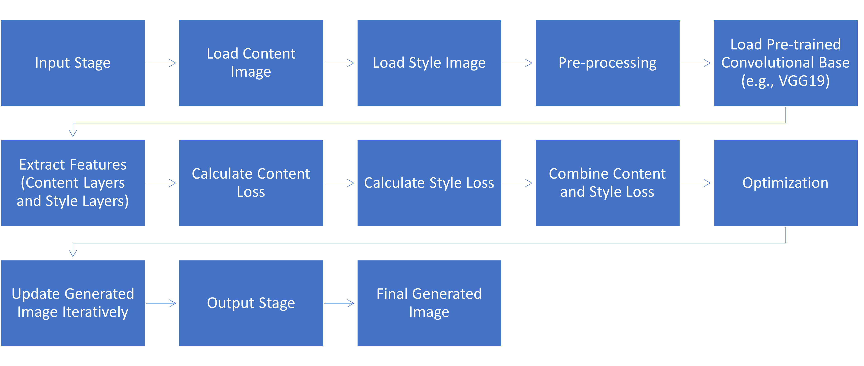**4.2 Architecture**

The architecture slide in our project documentation provides a concise overview of the neural style transfer process, showcasing the deep neural network framework for separating and recombining content and style features from input images to generate artistically stylized outputs.

1. User Interaction: Users provide content and style images through the interface.

2. Preprocessing: Input images are pre-processed to ensure compatibility with the chosen neural network.

3. Feature Extraction: The pre-trained convolutional base extracts content and style features from the input images.

4. Loss Calculation: Content loss and style loss are calculated based on the extracted features.

5. Loss Combination: Content loss and style loss are combined with user-defined weights.

6. Optimization: The optimization algorithm minimizes the total loss to update the generated image.

7. Iteration Loop: The generated image is iteratively updated until convergence.

8. Output Generation: The final stylized artwork is presented to the user.

This architectural overview outlines the flow of the art generation process with Neural Style Transfer, from user input to the generation of the final stylized image.

**4.3 UML Diagrams**

The system design for the art generation project with Neural Style Transfer comprises a user-friendly interface allowing users to upload content and style images. The architecture includes a pre-processing module for image normalization, a pre-trained convolutional base for feature extraction, and an optimization algorithm to iteratively update the generated image based on calculated content and style losses. The system aims for seamless user interaction, efficient feature extraction, and effective loss optimization, resulting in a visually appealing final stylized artwork.

**4.4 Use Case Diagram**

A use case diagram visually represents the interactions between actors and the system to illustrate the functionality of the system. In the context of our project on art generation with neural style transfer, the use case diagram showcases actors (users) interacting with the system to generate artistically stylized images through neural style transfer.

**4.5 Class Diagram**

The class diagram for our "Art Generation with Neural Style Transfer" project illustrates the key classes and their relationships, providing a structural overview of the system's components and interactions.

**4.6 Sequence Diagram**

A sequence diagram illustrates the interactions between different components or objects in a system over time, depicting the flow of messages or method calls between them. In our project, a sequence diagram can visually depict the flow of operations between components such as data preprocessing, neural network inference, and image rendering, elucidating the sequential steps involved in generating stylized artwork.

**4.7 Collaboration Diagram**

A collaboration diagram visually represents the relationships and interactions between objects or components within a system, depicting how they work together to achieve a common goal. In our project, a collaboration diagram showcases the cooperative efforts between modules such as data preprocessing, neural network inference, and image rendering to produce stylized artwork.

**4.8 Activity Diagram**

An activity diagram visually represents the flow of activities or processes within a system, showing the sequence of actions and decisions. It provides a clear overview of the steps involved in our project, such as data preprocessing, neural style transfer, and output generation, facilitating understanding of the workflow in art generation with neural style transfer.

**5. IMPLEMENTATION**

# **Artistic Neural Style Transfer using Pytorch.**

In this kernel, we’ll implement the style transfer method that is outlined in the paper, [Image Style Transfer Using Convolutional Neural Networks, by Gatys](https://www.cv-foundation.org/openaccess/content_cvpr_2016/papers/Gatys_Image_Style_Transfer_CVPR_2016_paper.pdf) in Pytorch.

In this paper, style transfer uses the features found in the 19-layer VGG Network, which is comprised of a series of convolutional and pooling layers, and a few fully connected layers. In the image below, the convolutional layers are named by stack and their order in the stack. Conv_1_1 is the first convolutional layer that an image is passed through, in the first stack. Conv_2_1 is the first convolutional layer in the second stack. The deepest convolutional layer in the network is conv_5_4.

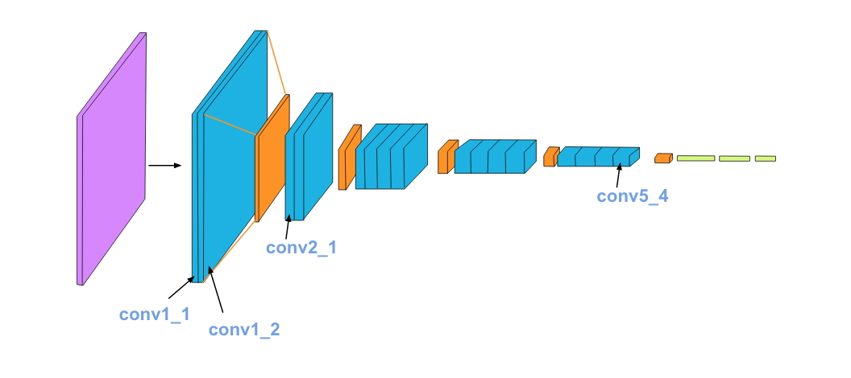

### **Separating Style and Content.**

Style transfer relies on separating the content and style of an image. Given one content image and one style image, we aim to create a new, target image which should contain our desired content and style components:

* objects and their arrangement are similar to that of the **content image.**
* style, colours, and textures are similar to that of the **style image.**

An example is shown below, where the content image is of a cat, and the style image is of [Hokusai's Great Wave](https://en.wikipedia.org/wiki/The_Great_Wave_off_Kanagawa). The generated target image still contains the cat but is stylized with the waves, blue and beige colours, and block print textures of the style image!

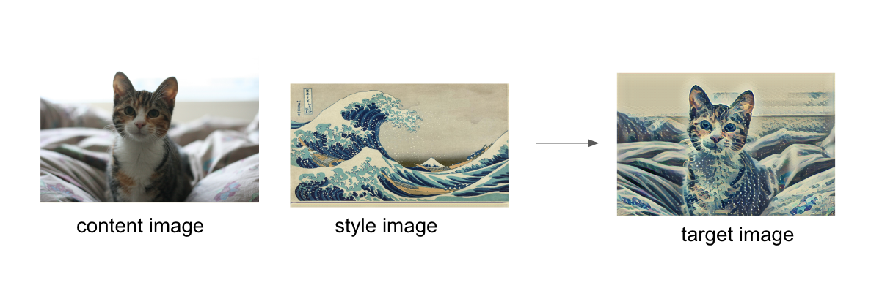

*# import resources*

%matplotlib inline

from PIL import Image

import matplotlib.pyplot as plt

import numpy as np

import torch

import torch.optim as optim

from torchvision import transforms, models

Load in VGG19 (features)

*# get the "features" portion of VGG19 (we will not need the "classifier" portion)*

vgg = models.vgg19(pretrained=True).features

*# freeze all VGG parameters since we're only optimizing the target image*

for param **in** vgg.parameters():

param.requires_grad_(False)

*# move the model to GPU, if available*

device = torch.device("cuda" if torch.cuda.is_available() else "cpu")

vgg.to(device)

### **Load in Content and Style Images**

def load_image(img_path, max_size=400, shape=None):

*''' Load in and transform an image, making sure the image*

*is <= 400 pixels in the x-y dims.'''*

image = Image.open(img_path).convert('RGB')

*# large images will slow down processing*

if max(image.size) > max_size:

size = max_size

else:

size = max(image.size)

if shape **is** **not** None:

size = shape

in_transform = transforms.Compose([

transforms.Resize(size),

transforms.ToTensor(),

transforms.Normalize((0.485, 0.456, 0.406),

(0.229, 0.224, 0.225))])

*# discard the transparent, alpha channel (that's the :3) and add the batch dimension*

image = in_transform(image)[:3,:,:].unsqueeze(0)

return image

Next, I'm loading in images by file name and forcing the style image to be the same size as the content image.

*# load in content and style image*

content = load_image('/kaggle/input/art-style-transfer/input_image/RKS.jpg').to(device)

*# Resize style to match content, makes code easier*

style = load_image('/kaggle/input/art-style-transfer/target_style/mona.jpg', shape=content.shape[-2:]).to(device)

*# helper function for un-normalizing an image*

*# and converting it from a Tensor image to a NumPy image for display*

def im_convert(tensor):

*""" Display a tensor as an image. """*

image = tensor.to("cpu").clone().detach()

image = image.numpy().squeeze()

image = image.transpose(1,2,0)

image = image * np.array((0.229, 0.224, 0.225)) + np.array((0.485, 0.456, 0.406))

image = image.clip(0, 1)

return image

*# display the images*

fig, (ax1, ax2) = plt.subplots(1, 2, figsize=(20, 10))

*# content and style ims side-by-side*

ax1.imshow(im_convert(content))

ax1.set_title("Content Image",fontsize = 20)

ax2.imshow(im_convert(style))

ax2.set_title("Style Image", fontsize = 20)

plt.show()

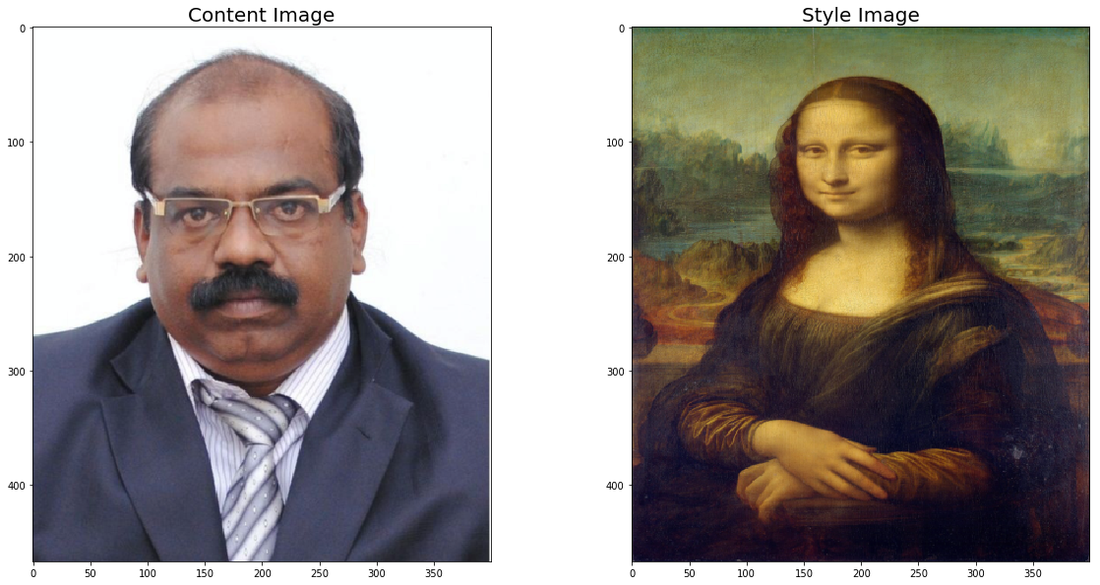

## VGG19 Layers

To get the content and style representations of an image, we have to pass an image forward through the VGG19 network until we get to the desired layer(s) and then get the output from that layer.

*# print out VGG19 structure so you can see the names of various layers*

print(vgg)

## Content and Style Features

def get_features(image, model, layers=None):

*""" Run an image forward through a model and get the features for*

*a set of layers. Default layers are for VGGNet matching Gatys et al (2016)*

*"""*

*## TODO: Complete mapping layer names of PyTorch's VGGNet to names from the paper*

*## Need the layers for the content and style representations of an image*

if layers **is** None:

layers = {'0': 'conv1_1',

'5': 'conv2_1',

'10': 'conv3_1',

'19': 'conv4_1',

'21': 'conv4_2', *## content representation*

'28': 'conv5_1'}

features = {}

x = image

*# model._modules is a dictionary holding each module in the model*

for name, layer **in** model._modules.items():

x = layer(x)

if name **in** layers:

features[layers[name]] = x

return features

## Gram Matrix

The output of every convolutional layer is a Tensor with dimensions associated with the batch size, a depth, d and some height and width (h, w). The Gram matrix of a convolutional layer can be calculated as follows:

* Get the depth, height, and width of a tensor using batch size, d, h, w = tensor. Size
* Reshape that tensor so that the spatial dimensions are flattened.
* Calculate the gram matrix by multiplying the reshaped tensor by its transpose.

*Note: You can multiply two matrices using torch.mm (matrix1, matrix2)*

def gram_matrix(tensor):

*""" Calculate the Gram Matrix of a given tensor*

*Gram Matrix: https://en.wikipedia.org/wiki/Gramian_matrix*

*"""*

*# get the batch_size, depth, height, and width of the Tensor*

_, d, h, w = tensor.size()

*# reshape so we're multiplying the features for each channel*

tensor = tensor.view(d, h * w)

*# calculate the gram matrix*

gram = torch.mm(tensor, tensor.t())

return gram

*# get content and style features only once before training*

content_features = get_features(content, vgg)

style_features = get_features(style, vgg)

*# calculate the gram matrices for each layer of our style representation*

style_grams = {layer: gram_matrix(style_features[layer]) for layer **in** style_features}

*# create a third "target" image and prep it for change*

*# it is a good idea to start of with the target as a copy of our *content* image*

*# then iteratively change its style*

target = content.clone().requires_grad_(True).to(device)

## Loss and Weights

*# weights for each style layer*

*# weighting earlier layers more will result in *larger* style artifacts*

*# notice we are excluding `conv4_2` our content representation*

style_weights = {'conv1_1': 1.,

'conv2_1': 0.75,

'conv3_1': 0.2,

'conv4_1': 0.2,

'conv5_1': 0.2}

content_weight = 1 *# alpha*

style_weight = 1e9 *# beta*

## Updating the Target & Calculating Losses

content_loss = torch.mean((target_features['conv4_2'] - content_features['conv4_2'])**2)

*# for displaying the target image, intermittently*

show_every = 400

*# iteration hyperparameters*

optimizer = optim.Adam([target], lr=0.003)

steps = 2000 *# decide how many iterations to update your image (5000)*

for ii **in** range(1, steps+1):

*# get the features from your target image*

target_features = get_features(target, vgg)

*# the content loss*

content_loss = torch.mean((target_features['conv4_2'] - content_features['conv4_2'])**2)

*# the style loss*

*# initialize the style loss to 0*

style_loss = 0

*# then add to it for each layer's gram matrix loss*

for layer **in** style_weights:

*# get the "target" style representation for the layer*

target_feature = target_features[layer]

target_gram = gram_matrix(target_feature)

_, d, h, w = target_feature.shape

*# get the "style" style representation*

style_gram = style_grams[layer]

*# the style loss for one layer, weighted appropriately*

layer_style_loss = style_weights[layer] * torch.mean((target_gram - style_gram)**2)

*# add to the style loss*

style_loss += layer_style_loss / (d * h * w)

*# calculate the *total* loss*

total_loss = content_weight * content_loss + style_weight * style_loss

*# update your target image*

optimizer.zero_grad()

total_loss.backward()

optimizer.step()

*# display intermediate images and print the loss*

if ii % show_every == 0:

print('Total loss: ', total_loss.item())

plt.imshow(im_convert(target))

plt.show()

Total loss: 15016456192.0

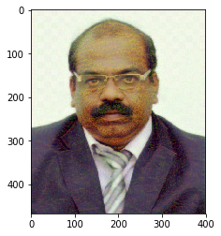

Total loss: 6737242112.0

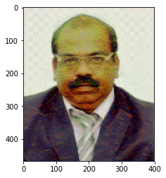

Total loss: 3311703040.0

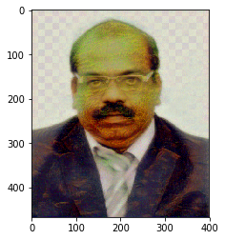

Total loss: 1866015872.0

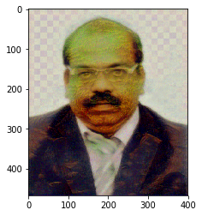

Total loss: 1183230464.0

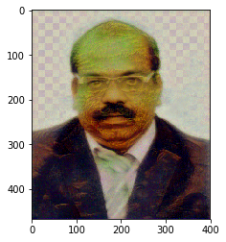

Display the Target Image

*# display content and final, target image*

fig, (ax1, ax2) = plt.subplots(2, 1, figsize=(15, 15))

ax1.imshow(im_convert(content))

ax1.set_title("Content Image", fontsize = 20)

ax2.imshow(im_convert(target))

ax2.set_title("Stylized Target Image", fontsize = 20)

ax1.grid(False)

ax2.grid(False)

*# Hide axes ticks*

ax1.set_xticks([])

ax1.set_yticks([])

ax2.set_xticks([])

ax2.set_yticks([])

plt.show()

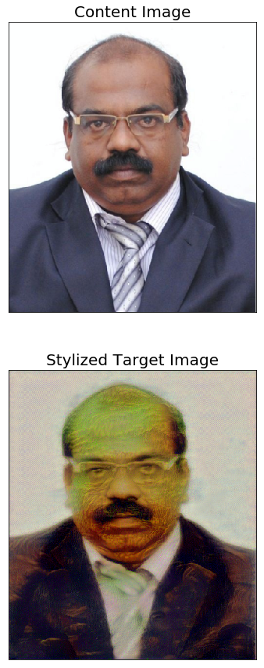

**Front end Implementation Using PyWebIo Interface**

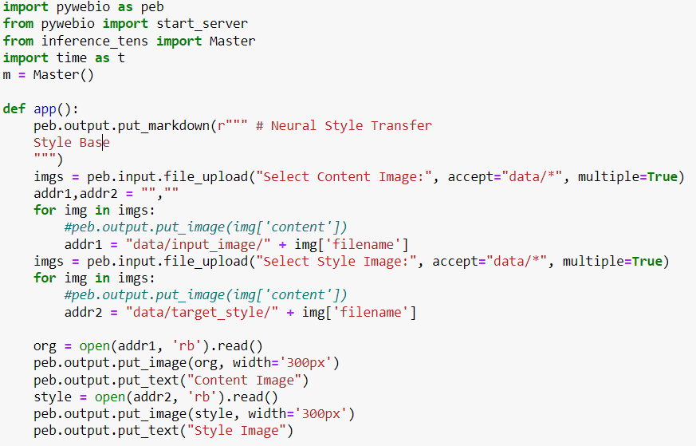

**5.2. Test Cases**

Testing an art generation project involving Neural Style Transfer (NST) typically involves verifying various aspects of the system, including functionality, performance, and usability. Here are some example test cases for an art generation project with NST.

1. Input Validation: Verify that the system properly handles invalid or unsupported input formats for content and style images. Ensure the system provides appropriate error messages for invalid inputs.
2. Style Transfer Accuracy: Validate that the generated artwork reflects the desired style characteristics from the style image. Compare the output artwork against expectations and benchmarks for style transfer quality.
3. Performance Testing: Measure the time taken by the system to perform style transfer on different sizes and complexities of content and style images. Test the system's scalability by evaluating its performance with large datasets or concurrent user requests.
4. Robustness and Error Handling: Verify that the system gracefully handles unexpected errors or exceptions during style transfer. Assess the system's fault tolerance and resilience to adverse conditions.
5. User Interface Testing: Evaluate the usability and intuitiveness of the user interface for uploading content and style images, adjusting parameters, and viewing results. Verify that the user interface provides clear feedback and guidance to users throughout the art generation process.
6. Compatibility Testing: Test the system's compatibility with different operating systems, web browsers, and hardware configurations.
7. Security Testing: Assess the system's security measures for protecting user data, such as uploaded images and personal information.
8. Integration Testing: Verify the integration between different system components, such as the NST model, user interface, and backend services.
9. Regression Testing: Re-run previously executed test cases to ensure that recent changes or updates have not introduced new defects or regressions.
10. User Acceptance Testing (UAT): Solicit feedback from end-users or stakeholders to assess the overall satisfaction with the system and its ability to meet user requirements.

These test cases provide a comprehensive framework for validating the functionality, performance, and quality of an art generation project with Neural Style Transfer.

**5.3. Results**

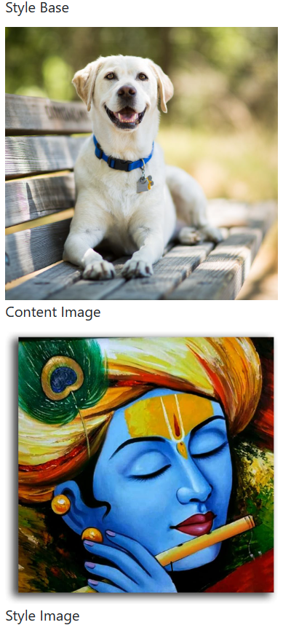

**Target Style Image**

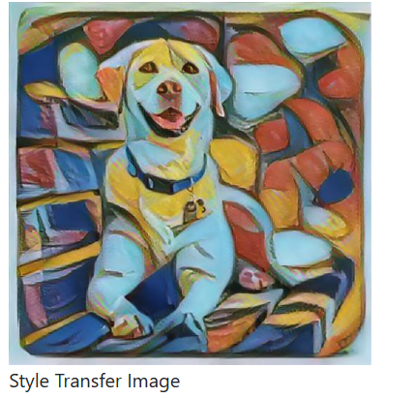

**6.Conclusion**

**6.1 Conclusion**

In conclusion, the project on art generation with Neural Style Transfer (NST) has demonstrated the potential to create captivating and visually appealing artworks by combining the content of one image with the style of another. Through the implementation of NST algorithms and the development of a user-friendly interface, the project has enabled users to explore their creativity and produce unique artistic compositions effortlessly.

The success of the project highlights several key points:

* Innovative Application of NST
* User-Centric Design
* Artistic Exploration
* Educational Value

**6.2. Future Scope**

Looking ahead, there are several avenues for future development and enhancement of the art generation project with NST:

1. Advanced Style Transfer Techniques: Explore and implement advanced NST algorithms, such as adaptive style transfer or multi-style transfer, to further enhance the diversity and quality of generated artworks.
2. Real-Time Processing: Optimize the NST model and algorithms to support real-time style transfer, enabling users to see immediate results as they interact with the application.
3. Customization and Personalization: Introduce features for users to customize and personalize their art generation experience, such as fine-tuning style parameters, combining multiple styles, or incorporating user-generated content.
4. Collaborative Art Creation: Enable collaborative art creation by allowing multiple users to contribute to the same artwork simultaneously, fostering collaboration and creativity among users.
5. Integration with Blockchain: Explore the integration of blockchain technology to provide provenance and authentication for generated artworks, creating a decentralized marketplace for buying, selling, and trading digital art.
6. AI Assistance and Recommendations: Implement AI-driven assistance and recommendation systems to provide users with personalized suggestions for styles, compositions, and artistic techniques based on their preferences and past interactions.

In summary, the project on art generation with NST has laid the foundation for a dynamic and engaging platform for digital art creation. With ongoing innovation and refinement, the project has the potential to evolve into a powerful tool for artistic expression, exploration, and collaboration in the digital age.

**References**

1. Gatys, L. A., Ecker, A. S., & Bethge, M. (2016). Image style transfer using convolutional neural networks. In Proceedings of the IEEE Conference on Computer Vision and Pattern Recognition (pp. 2414-2423).
2. Johnson, J., Alahi, A., & Fei-Fei, L. (2016). Perceptual losses for real-time style transfer and super-resolution. In European Conference on Computer Vision (pp. 694-711). Springer, Cham.
3. Li, Y., Fang, C., Yang, J., Wang, Z., Lu, X., & Yang, M. H. (2017). Universal style transfer via feature transforms. In Advances in Neural Information Processing Systems (pp. 386-396).
4. Chen, Y., Wang, M., Kuo, C. C. J., & Liao, H. Y. M. (2020). Universal style transfer via feature space translation. IEEE Transactions on Multimedia, 22(1), 120-133.
5. Dumoulin, V., Shlens, J., & Kudlur, M. (2017). A learned representation for artistic style. In International Conference on Learning Representations.
6. Ruder, M., Dosovitskiy, A., & Brox, T. (2016). Artistic style transfer for videos. In German Conference on Pattern Recognition (pp. 26-36). Springer, Cham.
7. Ulyanov, D., Vedaldi, A., & Lempitsky, V. (2016). Instance normalization: The missing ingredient for fast stylization. arXiv preprint arXiv:1607.08022.